Francis Lapointe

CS 361 Multithreading

Observations and expectations:

Thread Lock I expected an output of 20 million on the counter since both the pthread_create functions increment the counter by one 10 million times. This does in fact happen.

Thread Lock doesn’t appear to have the same issue as Thread 2 in the counter bugging out,

Thread race I was expecting a consistent result but noticed that the worker functions were working against each other with one incrementing counter and the other deincrementing it meaning occasionally A would be able to win after enough times of B winning. Thread 1 just outputted start and ends for both A and B while creating and joining using the pthread_create and pthread_join functions. Threads 2 on the other hand did not do what I expected, Occasionally the counter would output the wrong number with it outputting 17231445 instead of 2000000.

Outputs (ran each ~25-30 times):

Threads 1: 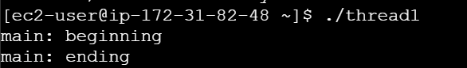

Thread 2:

Occasionally outputs counter incorrectly

Thread Race: Occasionally outputs -10 making A win but most of the time B wins.

Thread Lock:  
